**PRESS RELEASE**

**COMMUNICATIONS AND MEDIA TEAM OF THE 2023 ASEAN SUMMIT**

**No.26/SP/TKM-ASEAN2023/ENG/5/2023**

**West Manggarai Supports Success Organization of 42nd ASEAN Summit, Regent Says**

**Manggarai Barat, 5 Mei 2023** - West Manggarai Regent Edistasius Endi and all elements of society expressed their support for the successful organization of the 42nd ASEAN Summit 2023 in Labuan Bajo, West Manggarai Regency, East Nusa Tenggara Province on 9—11 May.

"Today's event is truly historic. Community leaders and youths pledged to dedicate themselves to being at the forefront to ensure the implementation of the ASEAN Summit in an orderly, safe, and peaceful manner," said Regent Edistasius in his remarks in the Declaration of Community Support for West Manggarai Regency to Secure and Succeed the Summit the 42nd ASEAN meeting at the Batu Cermin Cave in Labuan Bajo, Friday, 5 May.

West Manggarai Regent said the government appreciated the sincerity of all elements of society in the declaration.

He considered that the declaration was the essence of being a host, who was not merely a spectator but supported the security of activities as a representative of the Indonesian nation. "The government has entrusted Labuan Bajo as the host. So, if there is a commotion on the way, that is the big stake for the nation's dignity," he said.

He expressed his appreciation for the support from the Indonesian national army (TNI), Indonesian National Police (Polri), and elements of society. In particular, Regent Edi expressed his gratitude to the Polri because he had once held an international activity in NTT, namely the World Policewomen Conference.

"From that international moment, it became the starting point that we got up and moved to achieve the common good," said the Regent.

The declaration program also presented the Arri Meka dance for welcoming guests and signing the declaration.

The declaration was attended by Polri's Head of the Security Maintenance Agency, Police Commissioner General Muhammad Fadil Imran, NTT Regional Police Chief Johanis Asadoma, West Manggarai Deputy Regent Yulianus Weng, all elements of the West Manggarai Regional Leadership Coordination Forum (Forkopimda), and other community elements. (Francis MN Antara/Elvira/Rauf/WS/PPR).

***

For more information, please contact:

**Director General of Public Information and Communications of the Ministry of Communications and Informatics - Usman Kansong (0816785320)**

Get other information at <http://asean2023.id>, <https://infopublik.id/kategori/asean-2023>, and <https://indonesia.go.id/kategori/ragam-asean-2023>

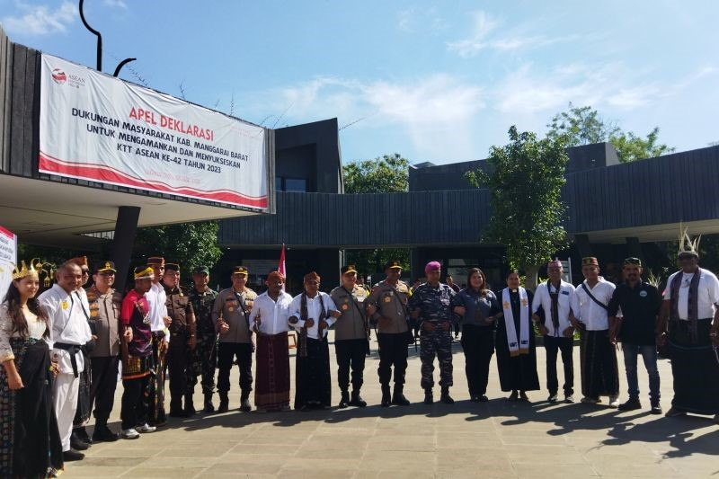

West Manggarai Regency Community Support Declaration to Secure and Succeed the 42nd ASEAN Summit in Batu Cermin Labuan Bajo Cave, West Manggarai, East Nusa Tenggara, Friday, 5 May 2023. (ANTARA/Franciska Mariana Nuka)